CS 305 Module Two Coding Assignment
- Run Dependency Check
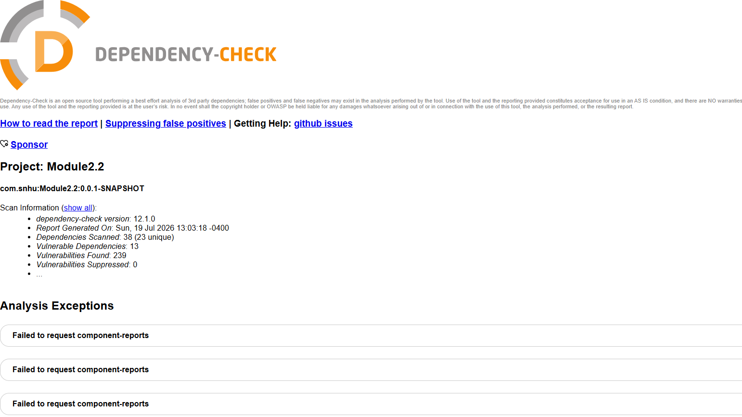
I ran the OWASP Dependency-Check Maven plugin against the Module2.2 project. The scan completed and generated a vulnerability report. The scan analyzed 38 dependencies and identified 13 vulnerable dependencies containing a total of 239 known vulnerabilities. Although the Maven build ended with a failure message, the vulnerability report was successfully generated. The build failure was caused by a Sonatype OSS Index authentication error (HTTP 401 Unauthorized), not by the dependency analysis itself.

- Document Results

The Dependency-Check report identified vulnerabilities in several third-party libraries used by the application, including:

Spring Framework
Spring Boot
Jackson Databind
Hibernate Validator
Logback
Log4j
MongoDB Java Driver
SnakeYAML
Apache Tomcat Embedded

Some examples of identified vulnerabilities include:

CVE-2022-22965 (Spring Framework), commonly known as "Spring4Shell"
CVE-2020-36518 (Jackson Databind)
CVE-2022-1471 (SnakeYAML)
CVE-2021-20328 (MongoDB Java Driver)

The dependency with the largest number of reported vulnerabilities was the older version of Tomcat Embedded Core (9.0.30). Many of the vulnerabilities identified stem from the fact that the project uses older dependency versions that have known security issues.

- Analyze Results

The results show that several dependencies in the application are outdated and contain known vulnerabilities. These vulnerabilities could potentially allow attackers to perform remote code execution, denial-of-service attacks, deserialization attacks, or other malicious actions if left unpatched.

The highest-priority findings include vulnerabilities affecting Spring Framework, Tomcat, Jackson Databind, and SnakeYAML because these components are directly involved in processing web requests and application data. Exploitation of these vulnerabilities could compromise the confidentiality, integrity, or availability of the application.

To mitigate these risks, developers should regularly update dependencies to supported versions, monitor vulnerability reports, and incorporate automated security testing tools such as OWASP Dependency-Check into the software development lifecycle. Performing routine dependency scans helps identify vulnerable components early and reduces the likelihood of security incidents in production environments.

